Week 7 경현

This week’s task:

**Creating general models using transfer learning on pretrained networks**

1. Overview

In the last week’s task, validation accuracy was increased to 70% through data augmentation, but this is not a high number in terms of accuracy. In this task, we use transfer learning in addition to data augmentation to maximize the image classification accuracy of our model.

2. Procedure

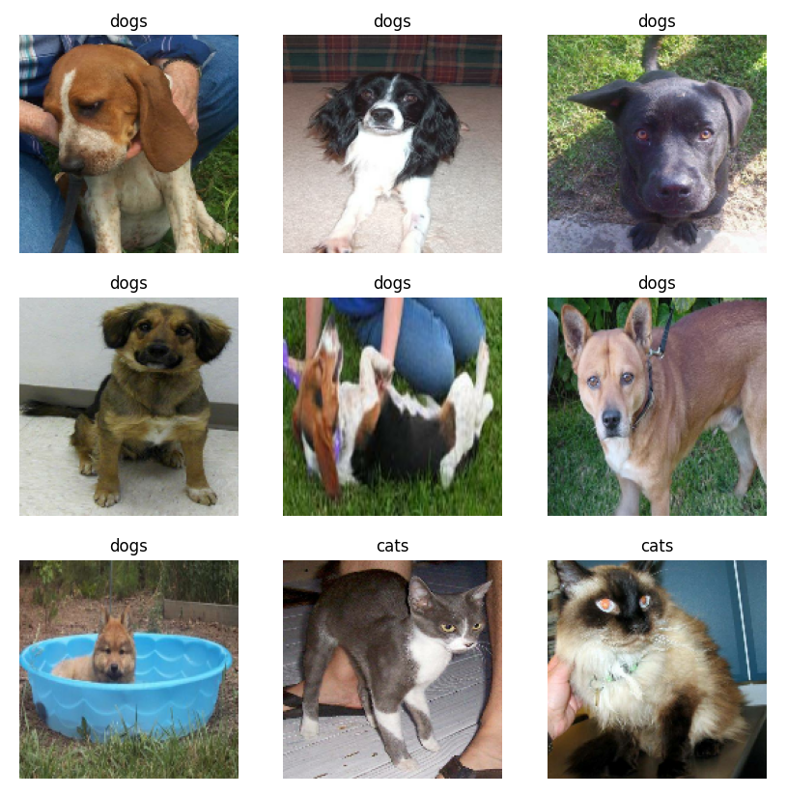

Figure 1. Images to train (Line 18~25)

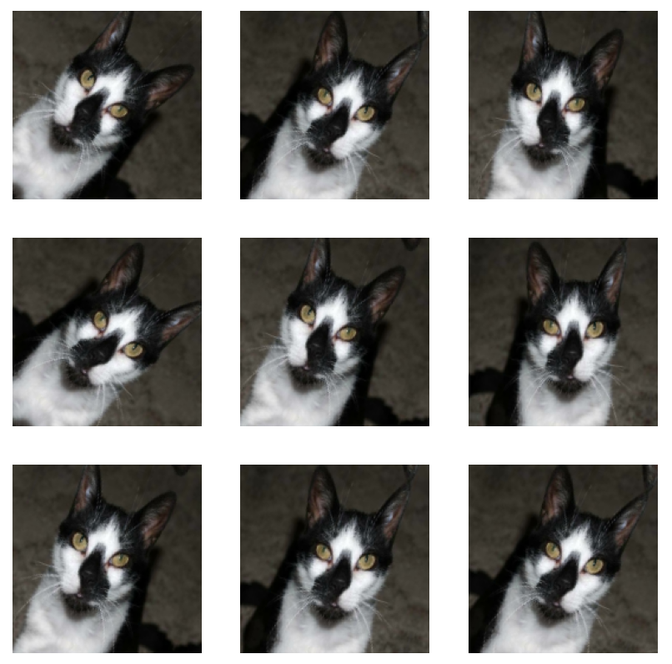

Figure 2. Data augmentation (Line 36)



Figure 3. Initial result (Line 72~77)

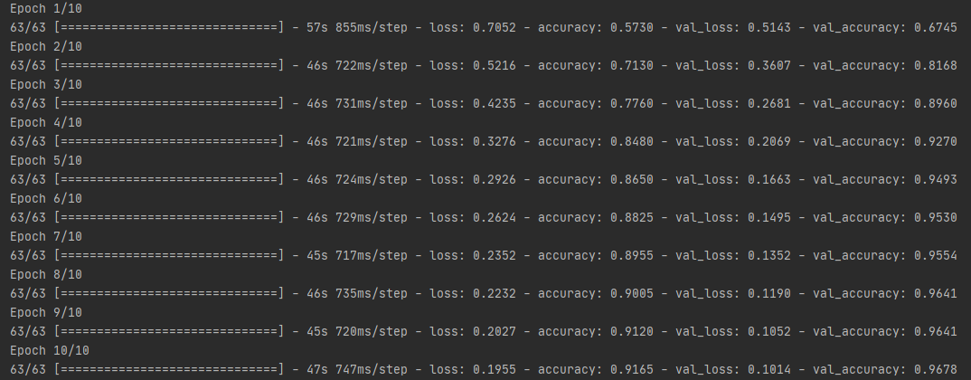

Figure 4. Applying transfer learning (Line 79~83)

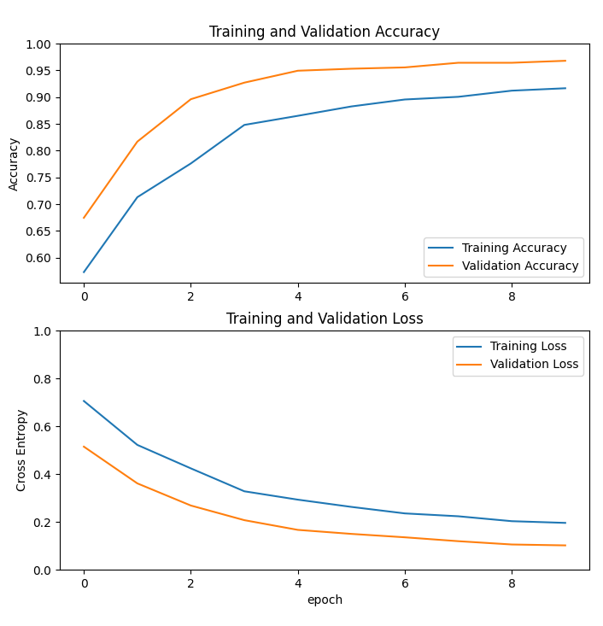

Figure 5. Final result (Line 85~92, 94~102)

Next week’s task:

In this week's task, we learned how to increase the accuracy of an image classification model to 95%. In the next task, we will use this model to classify fashion images that we will actually use and store the results.